Small Group Projects – Lecturer copy

These three group projects are designed to encourage students and trainees to consider the professional and legal responsibilities for establishing an online practice

Project 1: Small research projects utilising feedback from online counselling and guidance skills practitioners

Students and trainees are required to compile a questionnaire whilst conducting research with willing practitioners who are prepared to discuss their views on engaging with clients using computer-mediated technology. Students may elect to focus on variations in their research questions and these may be structured on the subject matter within each chapter of the book or focus on specific chapter content.

Rationale of the project
This project will assist students in gaining a first-hand view from practitioners who are engaged with online clients and therefore have a wealth of experience which can assist in the consolidation of learning and understanding of differing approaches within this filed of practice. The project could include further variation by encouraging students to approach practitioners from a broad range of service delivery and areas of specialism.
An example of how one group of students might structure the content of their questionnaire might be on the subject of client assessment and the practice of contracting. This would bring a diverse range of approaches which online practitioners adopt, and potentially provide example contracts which students could compare.

Below is a summary of chapter titles and their content which can be suggested to students as a focus for compiling questionnaires and questions they would wish to ask practitioners:

Chapter One: The Foundations
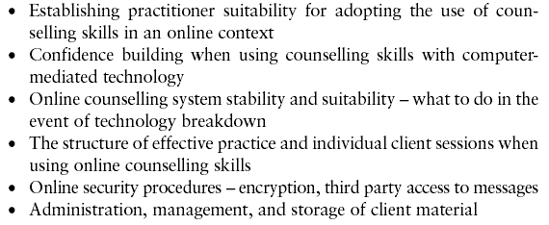

Chapter Two: Establishing an Online Presence
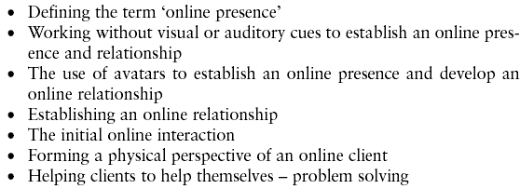

Chapter Three: Online Expression
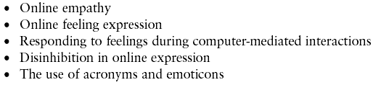

Chapter Four: Online Listening, Attunement and Attending to the Client
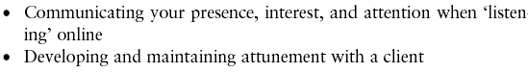

Chapter Five: Establishing and Maintaining an Open Dialogue
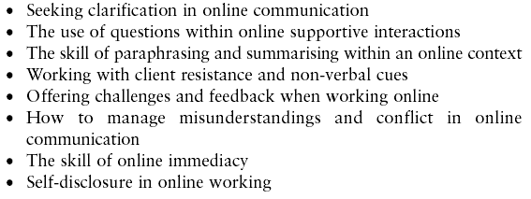



Chapter Six: Online Assessment and Contracting
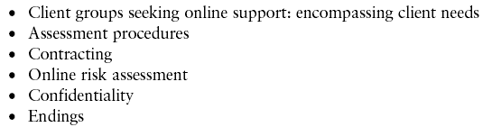

Chapter Seven: Professional Considerations in Online Practice
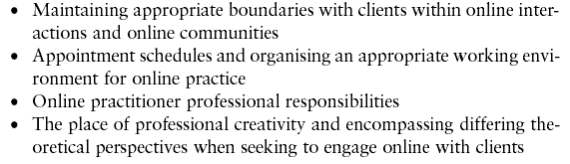

Chapter Eight: Professional guidelines for online practice
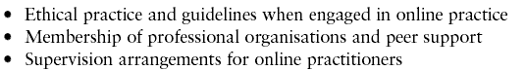

Project 2
Projects 2 and 3 can be connected or stand alone as a shared group activity.
Within this project students are required to consider how a specific field of face-to-face client practice could be adapted to feature as an online service delivery. An example of this might be where students are engaged in study relating to careers guidance, or client support where there is not an established format to identify the structure of an online client service. The student group are therefore asked to consider all facets of how an effective online service could be achieved using the direction from within each chapter of the book to consider such matters as:

Chapter 1
- Establishing practitioner suitability for adopting the use of counselling
skills in an online context
- Confidence building when using counselling skills with computer-
mediated technology
- Online counselling system stability and suitability − what to do in the event of technology breakdown
- The structure of effective practice and individual client sessions
when using online counselling skills
- Online security procedures – encryption, third party access to messages
- Administration, management and storage of client material

Chapter 6
- Assessment procedures
- Contracting
- Online risk assessment
- Confidentiality

Chapter 7
- Maintaining appropriate boundaries with clients within online interactions and online communities
- Appointment schedules and organising an appropriate working environment for online practice
- Online practitioner professional responsibilities:
Referral
  - Working online and encompassing diversity issues
  - Insurance
  - Verification of practitioner identity and credentials
- The place of professional creativity and encompassing differing theoretical perspectives when seeking to engage online with clients

Chapter 8
- Ethical practice and guidelines when engaged in online practice
- Membership of professional organisations and peer support
- Supervision arrangements for online practitioners

Rationale of the project
In addition to the practical online counselling and Guidance skills required to conduct an effective online practice, there are additional considerations which fall within the professional, ethical, and legal requirements of online practitioners and online client services. This project will encourage thought by students in how such matters apply within their specific area of professional practice and promote increased awareness of how these might be successfully applied to form an appropriate format of service delivery.

Project 3
As previously mentioned, this project could be stand alone or combined with Project 2. Within this project students are provided with the task of structuring a model website, or home page of a website, which is designed to provide an appropriate public ‘shop window’ for a chosen organisation offering an online client facility, or range of facilities. The model website design maybe compiled as a hard paper copy, PowerPoint presentation, wiki page, blog, or by utilising a free website package such as: www.build-your-website.co.uk/ or www.doyourownsite.co.uk/. These website building resources are free for a limited period, which would give students the opportunity to construct a model example without cost.

Rationale of the project
Students will be encouraged to consider what information they would need to provide to potential clients that complies with the professional, ethical and legal responsibilities required within this field of practice. It will also encourage students to consider what might generate a positive experience for potential clients when first accessing an online counselling, guidance, or support resource.
This project would hold particular relevance to the content of chapters 6−8 of the book, and therefore tutors might suggest that students focus on the content of thes chapters prior to commencing the project.

