References

PART I: PRACTICAL SKILLS

Chapter 1: The Foundations – A Framework for Practice when using Online Counselling Skills

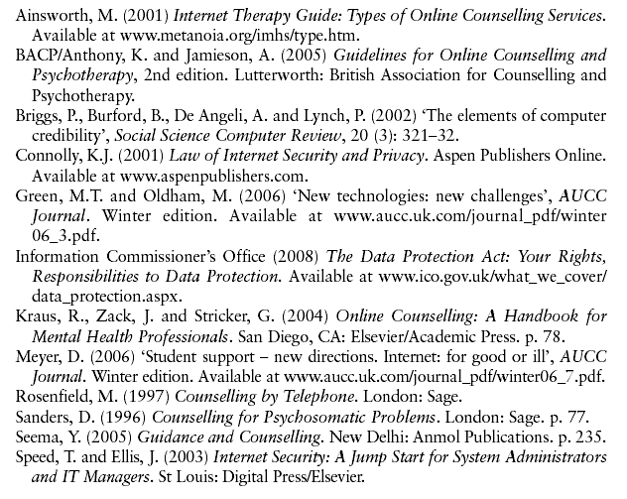
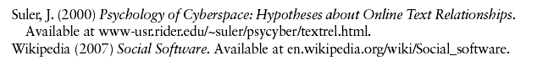

Chapter 2: Establishing and Online Presence and Online Relationship

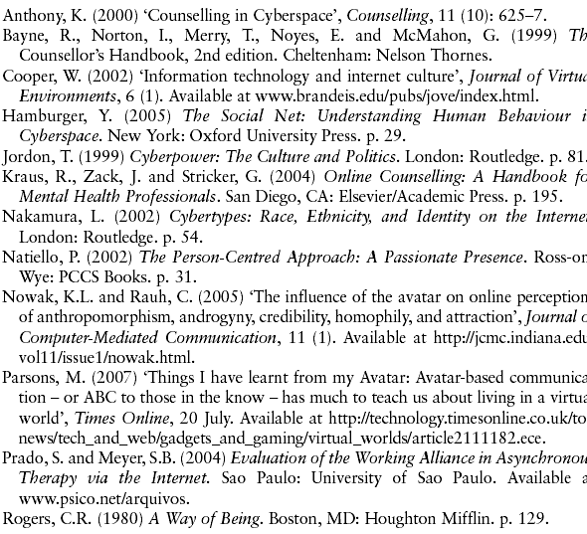
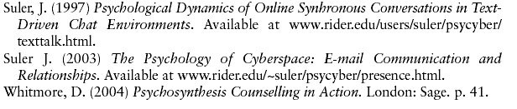

Chapter 3: Online Expression

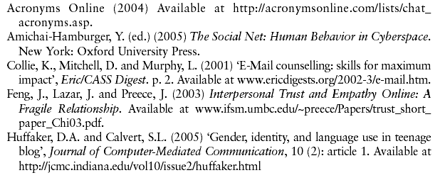
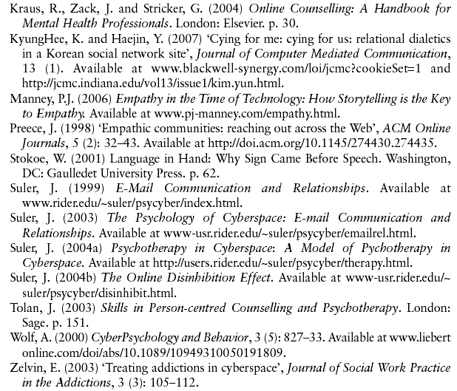

Chapter 4: Online Listening, Attunement and Attending to the Client

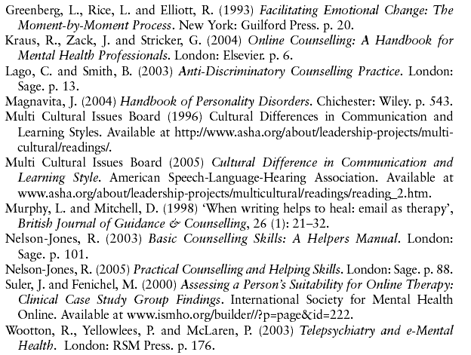

Chapter 5: Establishing and Maintaining an Open Dialogue

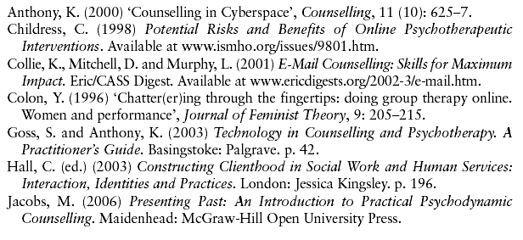
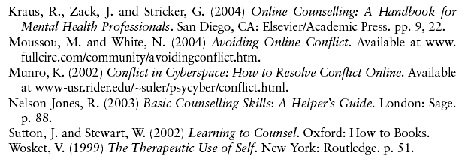

PART II: PROFESSIONAL CONSIDERATIONS

Chapter 6: Online Assessment and Contracting

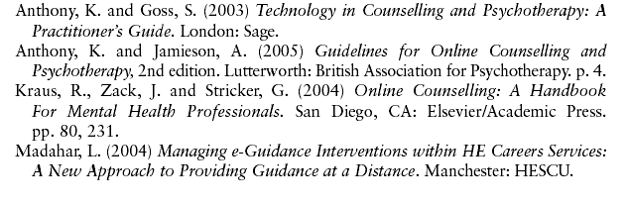
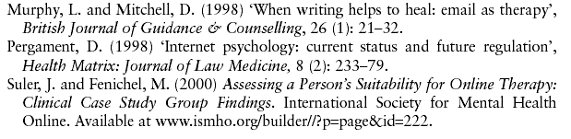

Chapter 7: Professional Considerations in Online Practice

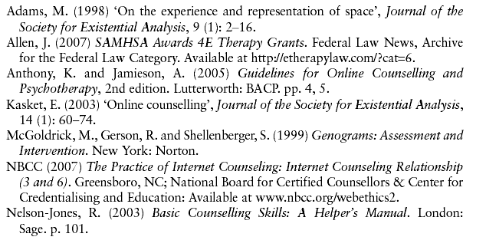
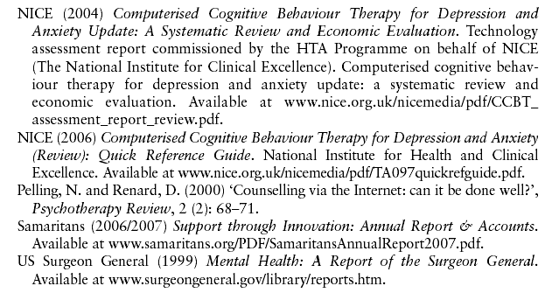

Chapter 8: Professional Guidelines for Online Practice

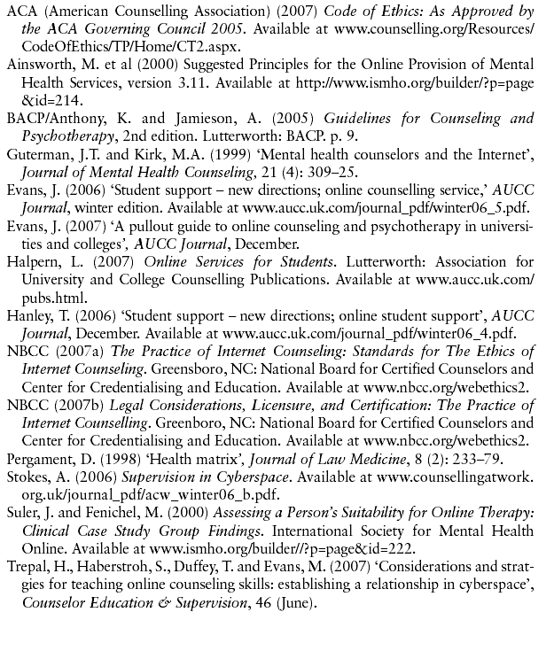
Conclusion

